Question 1: Baby Name Trends

# Introduction

This report explores US baby naming trends from 1910–2014 to identify patterns in naming persistence and cultural influences behind sudden name surges. Using the provided datasets and supplementary media data, I investigated how names rise and fall in popularity and what drives those changes.

# Methodology

## I used the following data:

* **Baby_Names**: Count of names by state, year, and gender.
* **Top_100_Billboard**: Weekly Billboard songs since 1958.
* **HBO_titles, HBO_credits**: TV character data with IMDb scores.

## And using this, I examined :

* Name persistence using Spearman rank correlation over consecutive years.
* Name spikes via year-on-year changes.
* Cultural drivers by cross-referencing media influence.

# Results: Spearman Correlation of Top 25 Names

knitr::include_graphics("../Figures/spearman_name_correlation.png")

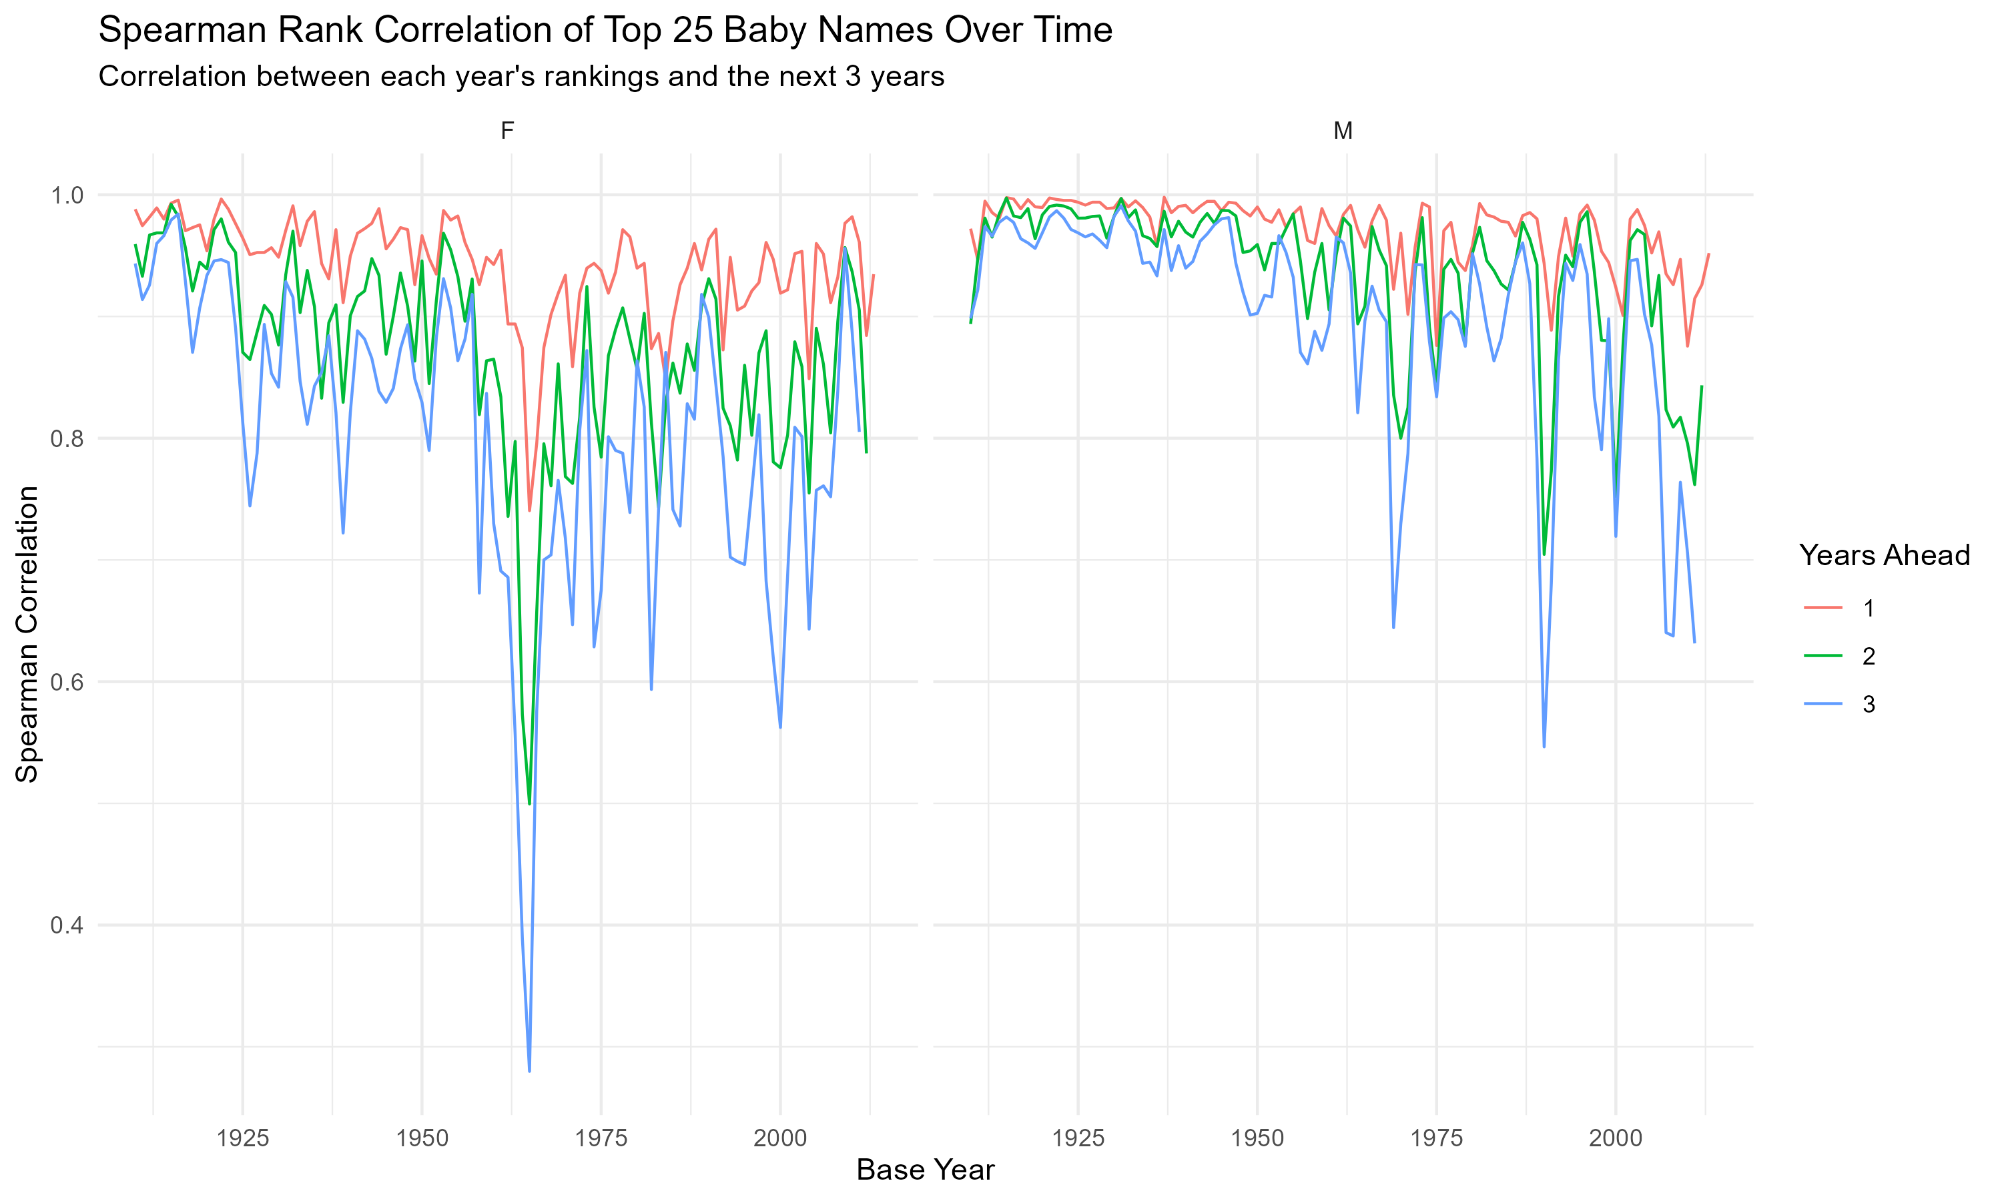

## Summary:

* We see that both male and female names show strong short-term persistence (especially 1–2 years).
* This persistence tends to weaken slightly over longer time gaps (3+ years), with greater fluctuation in female names.
* A sharp dip in correlation appears around 1950 for female names, indicating a potential shift in naming preferences or a broader societal change.

# Results : Top Name surges over time

knitr::include_graphics("../Figures/top_name_surges.png")

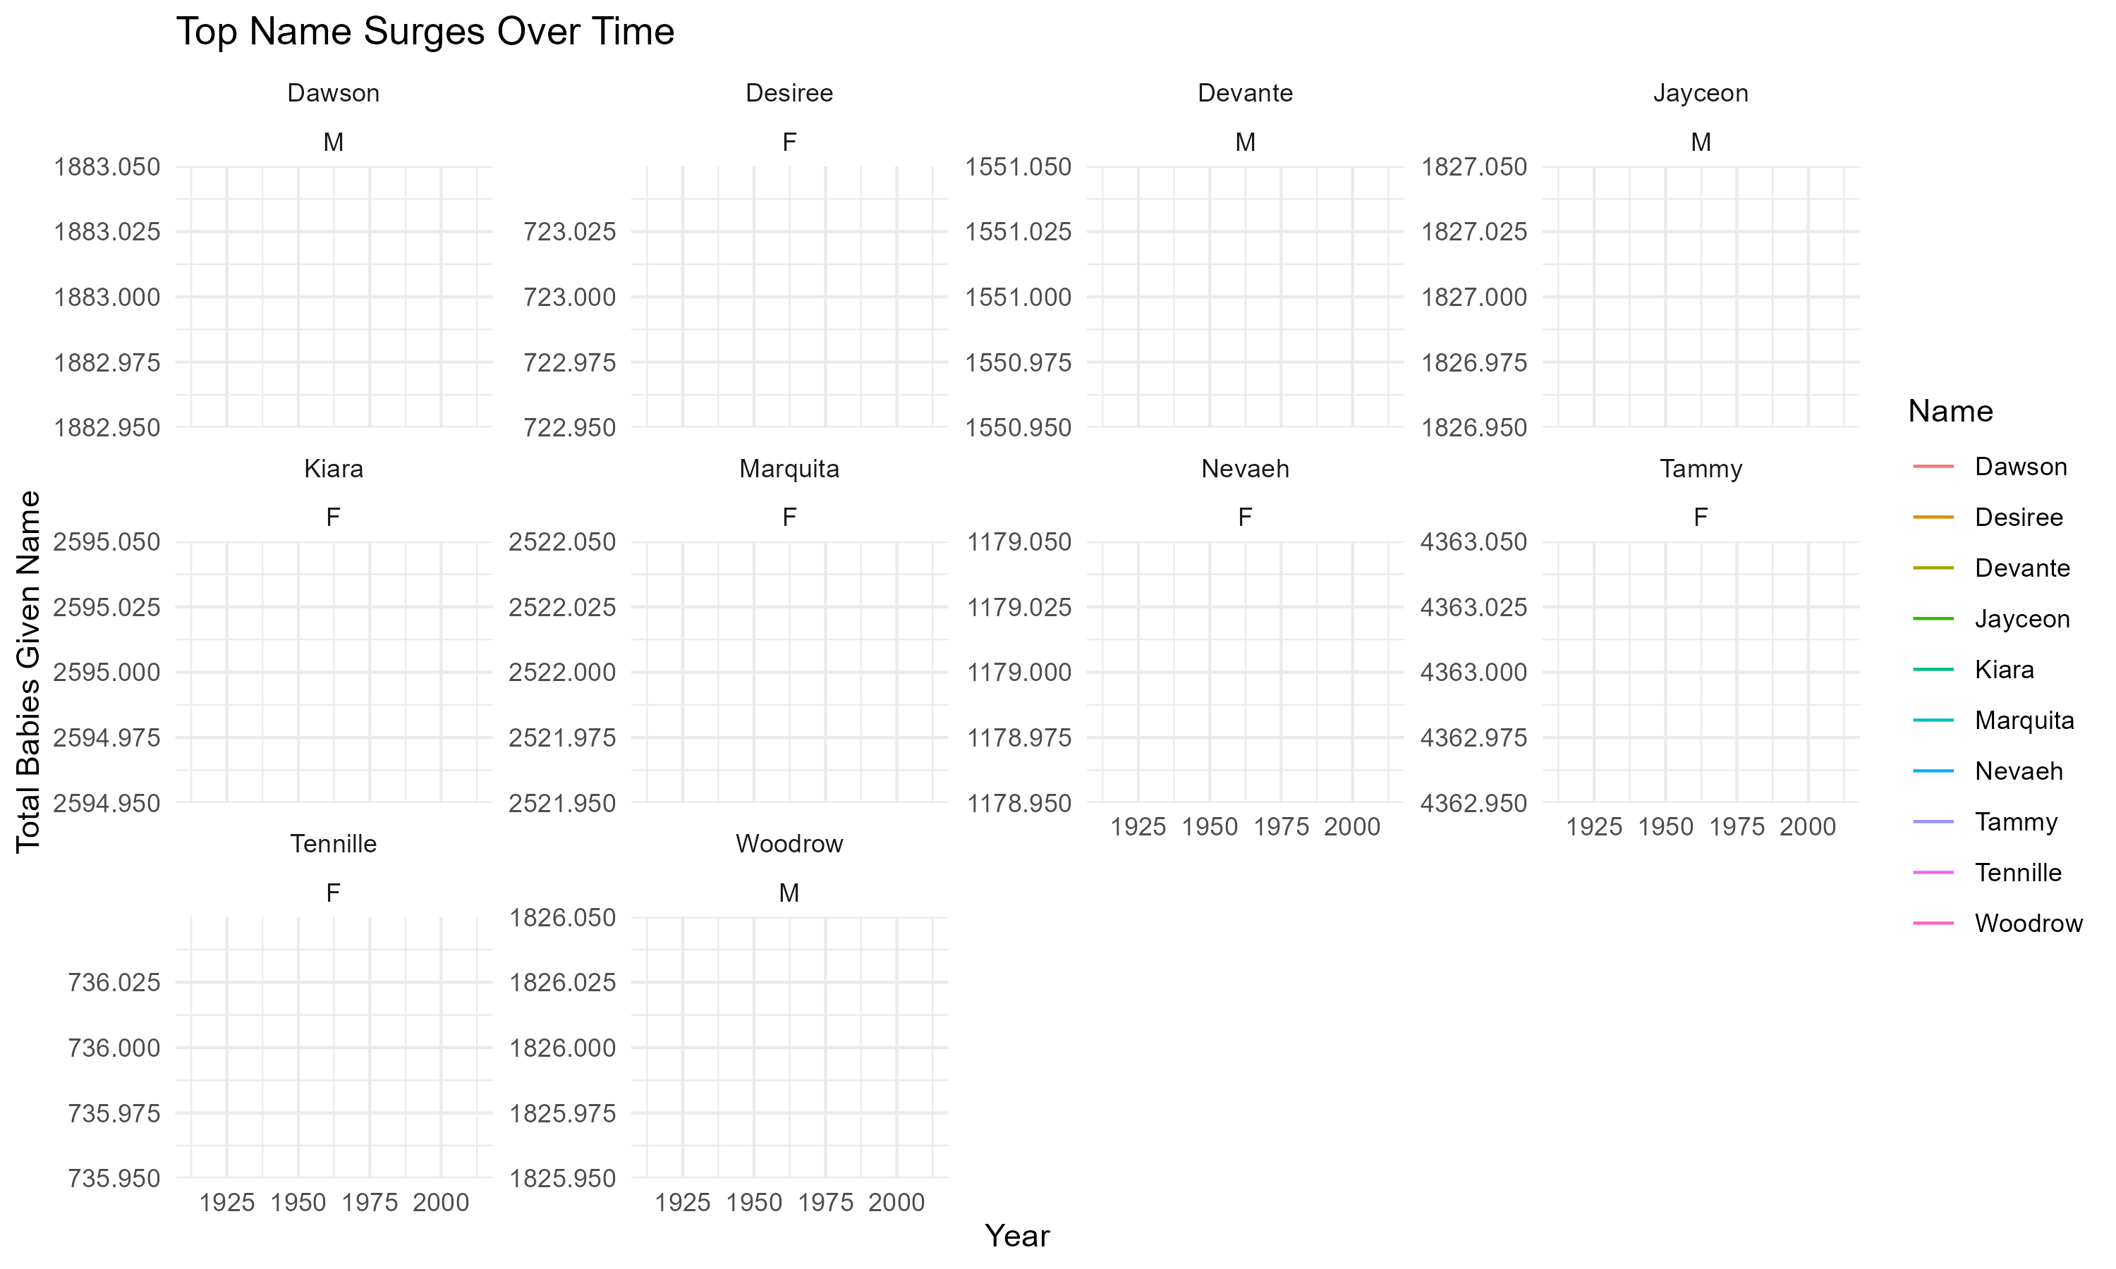

These year-on-year name surges highlight the impact of societal events and media exposure on naming decisions. I examined the top 10 names with the greatest year on year growth in count and investigated likely cultural explanations using public knowledge and media trends.

## From the above figure we can uncover several interesting naming insights :

**1. Nevaeh (F)**  
- Surge Period: Early 2000s  
- Origin: “Heaven” spelled backward.  
- Potential cause: This name may have been popularized by Sonny Sandoval (lead singer of group P.O.D.), who named his daughter Nevaeh in 2000 and discussed it on MTV’s *Cribs*. Thereafter the name rapidly gained traction as a unique but meaningful name.  
- Insight: This name illustrates how even personal celebrity moments can influence national naming trends.

**2. Jayceon (M)**  
- Surge Period: Early to mid-2010s  
- Potential Cause: This is the birth name of famous West Coast rapper *The Game* (Jayceon Terrell Taylor). He gained popularity in the mid-2000s and remained in the public eye into the 2010s.  
- Insight: This showcases the power and influence of modern music artists as they can drive adoption of less traditional, unique names — especially within pop/hip-hop.

**3. Devante (M)**  
- Surge Period: 1990s  
- Cause: This name is likely linked to *DeVante Swing*, who was a key member of the influential 90s R&B group *Jodeci*.  
- Insight: The rise of R&B culture during the 90s strongly influenced naming among urban communities.

**4. Kiara (F)**  
- Surge Period: Late 1990s  
- Cause: This is the name of Simba’s daughter in Disney’s *The Lion King II: Simba’s Pride* (1998).  
- Insight: Showcases the power of animated films — especially sequels to beloved classics. These films can leave cultural imprints on younger parents thus influencing how they name children.

**5. Desiree (F)**  
- Surge Period: 1970s–1980s  
- Cause: This surge was likely media-related, possibly linked to the 1954 movie *Desirée* (featuring Napoleon’s lover) or resurgence due to TV or music mentions. - Insight: Shows us that romantic-sounding names tied to fictional or historical characters can resurge decades later.

We then examined whether these names had links to Billboard chart-topping songs or popular HBO media titles at the time of their spikes.

top_surges_summary <- read.csv("../Figures/top_surges_summary.csv")  
knitr::kable(top_surges_summary, caption = "Summary of Top Name Surges and Media Links")

Summary of Top Name Surges and Media Links

| Name | Gender | Year | YoY_change | Billboard_Link | HBO_Link |
| --- | --- | --- | --- | --- | --- |
| Marquita | F | 1983 | 2527.083 | TRUE | TRUE |
| Woodrow | M | 1912 | 2126.829 | TRUE | TRUE |
| Nevaeh | F | 2001 | 2124.528 | TRUE | TRUE |
| Tammy | F | 1957 | 2038.725 | TRUE | TRUE |
| Devante | M | 1992 | 1703.488 | TRUE | TRUE |
| Kiara | F | 1989 | 1417.544 | TRUE | TRUE |
| Jayceon | M | 2013 | 1327.344 | TRUE | TRUE |
| Tennille | F | 1976 | 1288.679 | TRUE | TRUE |
| Dawson | M | 1998 | 1235.461 | TRUE | TRUE |
| Desiree | F | 1955 | 1214.545 | TRUE | TRUE |

From the above table we can see that :

* All ten names that experienced the largest year-on-year surges in popularity had clear associations with mainstream media, either through Billboard chart hits or HBO shows/movies.
* HBO Link Examples:

The name Tammy appears in multiple HBO series during the 1980s and 1990s, likely aligning with visibility in adult television content. The spikes

The name Woodrow features in historical or political dramas. This is consistent with naming patterns influenced by serious roles or periods.

* Billboard Mentions:

Desiree and Devante were tied to 90s R&B culture — particularly through artists like Jodeci and Des’ree who were active during their spikes.

Jayceon, as mentioned, aligns with the rapper The Game, whose peak years coincide with the surge.

Marquita may reflect naming influence from lesser-known hits or regional artist recognition not immediately visible in national charts.

Patterns & Hypothesis :

The synchrony of name surges and cultural media activity supports the agency’s hypothesis that children’s names are indeed influenced by pop culture visibility.

Names influenced by music and TV show characters appear to enjoy temporary spikes but may lack long-term persistence unless reinforced (e.g., Tammy had multiple resurgence periods).

Business Takeaway/Insights:

For the toy design agency, understanding which media formats (TV, music) drive naming trends can aid in selecting names that will resonate with the market. These findings could guide branding strategies, packaging, and even character development decisions tied to name trends.